Internal-Cavity Subtraction.

Definition
# Source: AI Source: Provided by: [Data Path: Persons Table -> ID Column: 1, Name_En Column: Motasem Essam] -> From: [ChatGPT] on [7/25/2026]
Internal-Cavity Subtraction is a method of forming a hollow or partially hollow solid by removing material from an interior region of an existing solid, creating an enclosed or partially enclosed empty space called a cavity.
Unlike a surface depression, which opens directly onto an outer face, an internal cavity is generally enclosed by the remaining material. It may be connected to the exterior through a small opening, passage, or access channel, or it may be completely sealed inside the solid.
The resulting solid contains an internal empty region bounded by newly exposed internal surfaces.

Simple Definition
# Source: AI Source: Provided by: [Data Path: Persons Table -> ID Column: 1, Name_En Column: Motasem Essam] -> From: [ChatGPT] on [7/25/2026]
Internal-cavity subtraction means removing material from inside a solid to create an internal empty space or hollow region.

Geometric Representation
# Source: AI Source: Provided by: [Data Path: Persons Table -> ID Column: 1, Name_En Column: Motasem Essam] -> From: [ChatGPT] on [7/25/2026]
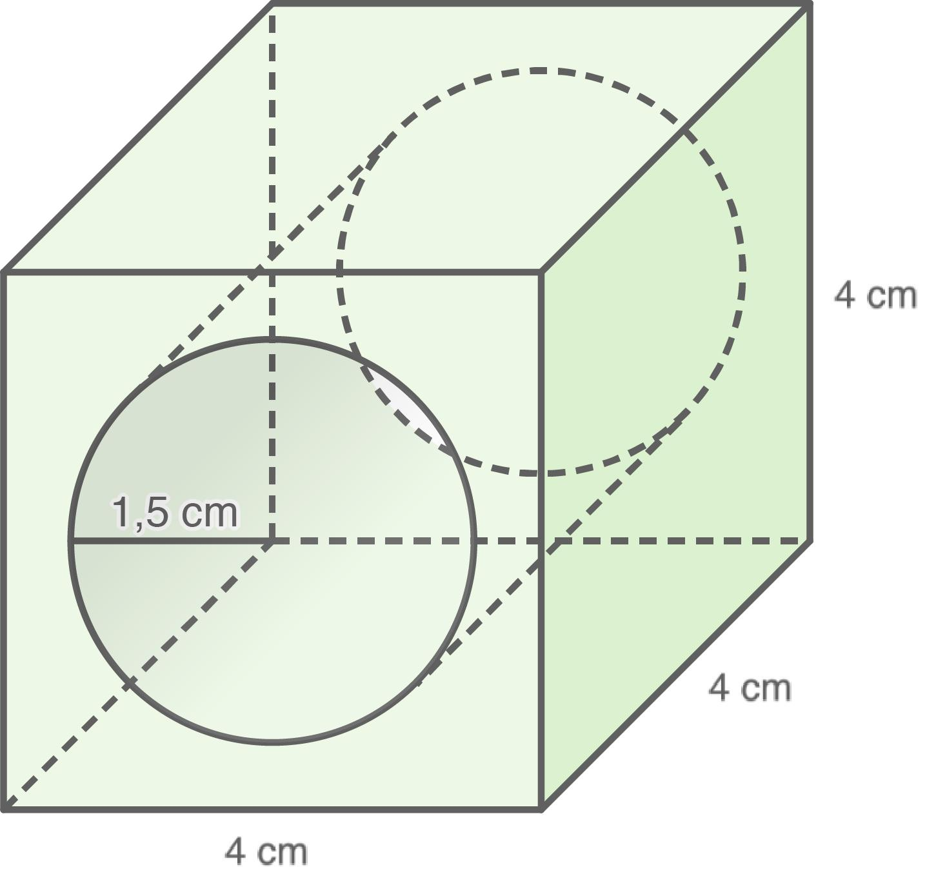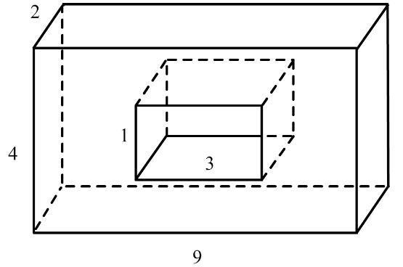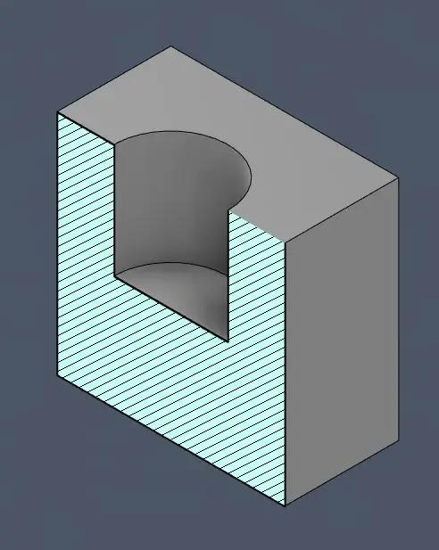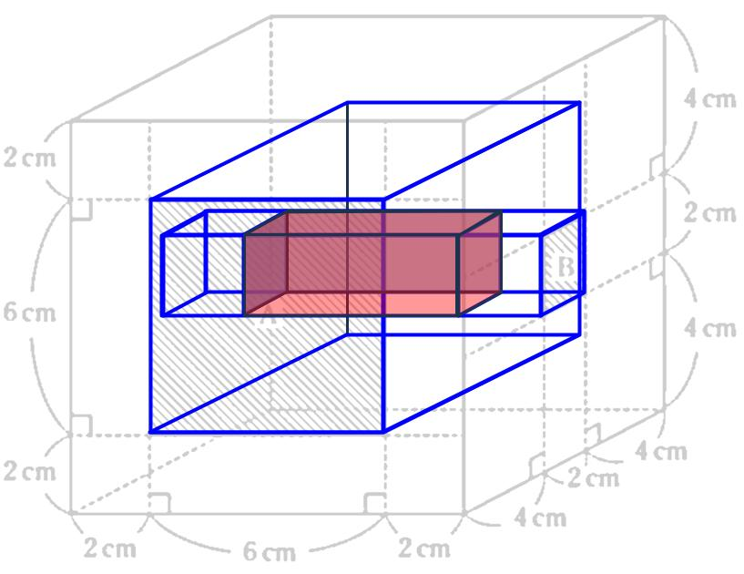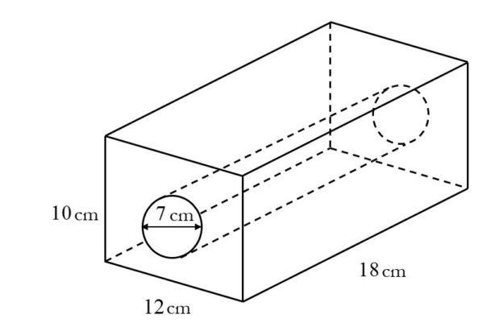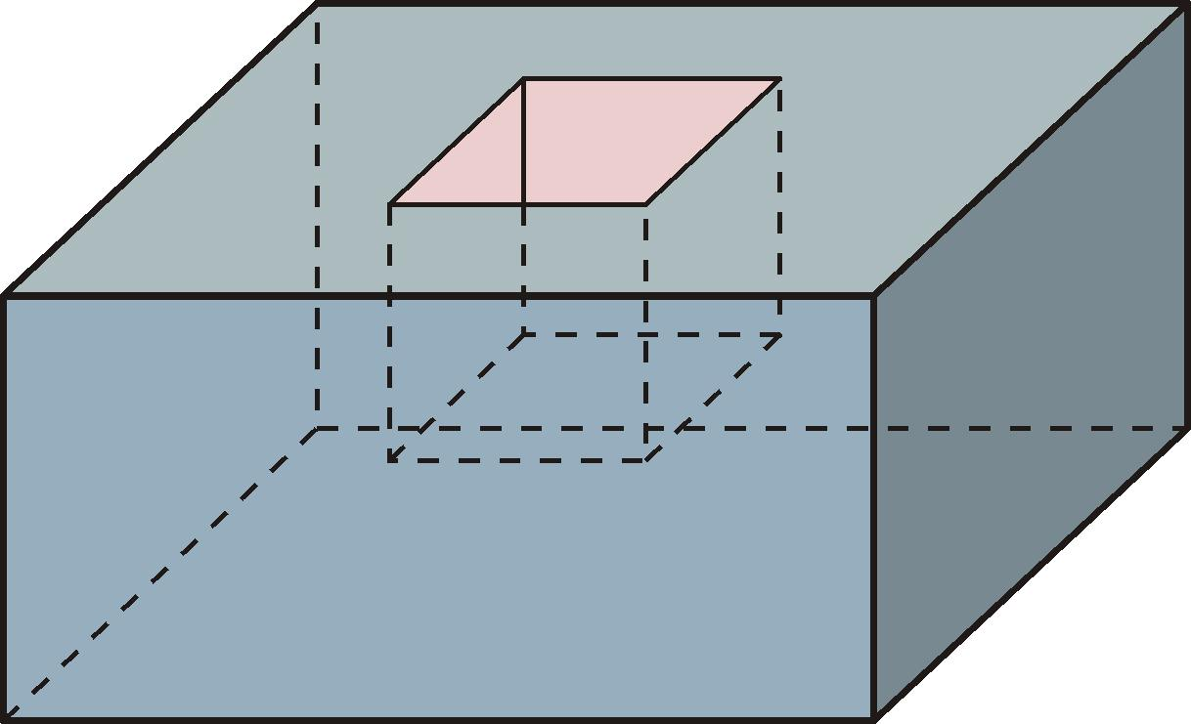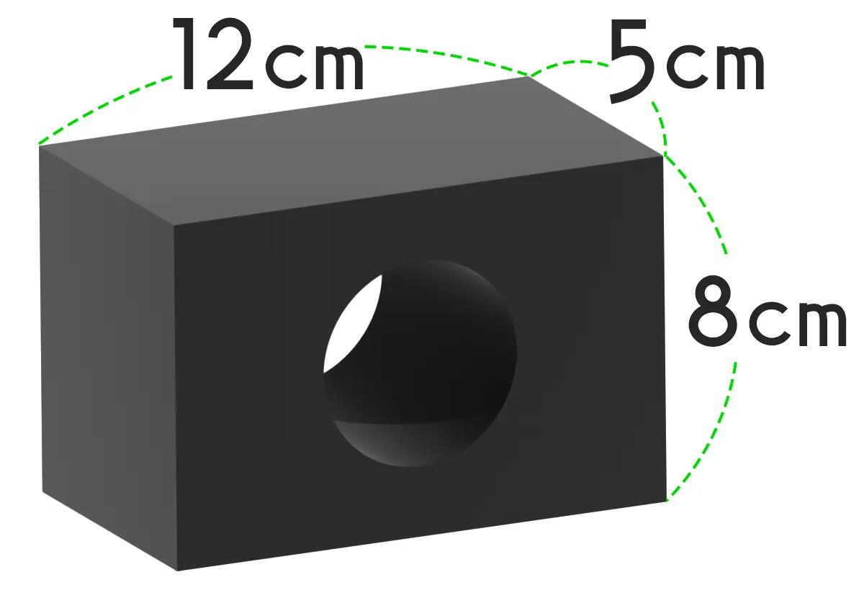
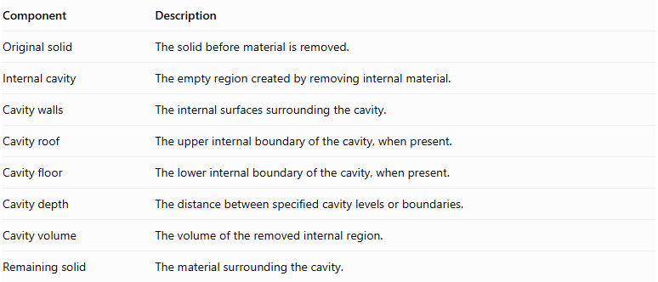
Component | Description
Original solid | The solid before material is removed.
Internal cavity | The empty region created by removing internal material.
Cavity walls | The internal surfaces surrounding the cavity.
Cavity roof | The upper internal boundary of the cavity, when present.
Cavity floor | The lower internal boundary of the cavity, when present.
Cavity depth | The distance between specified cavity levels or boundaries.
Cavity volume | The volume of the removed internal region.
Remaining solid | The material surrounding the cavity.

Main Classification
# Source: AI Source: Provided by: [Data Path: Persons Table -> ID Column: 1, Name_En Column: Motasem Essam] -> From: [ChatGPT] on [7/25/2026]
Internal-cavity subtraction can be classified according to the geometric shape of the removed internal region.

Rectangular Internal-Cavity Subtraction
# Source: AI Source: Provided by: [Data Path: Persons Table -> ID Column: 1, Name_En Column: Motasem Essam] -> From: [ChatGPT] on [7/25/2026]
Material is removed from the interior of a solid to create a rectangular cavity.
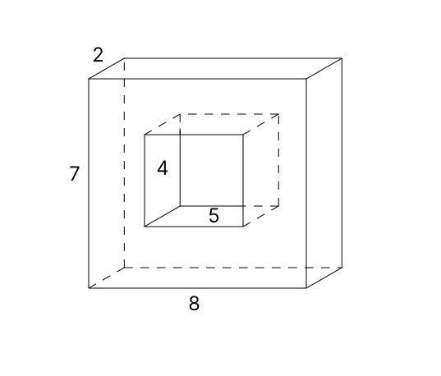
- Cavity shape: Rectangular prism.
- Walls: Six rectangular boundary faces.
- Example: A rectangular hollow space inside a block.

Cubical Internal-Cavity Subtraction
# Source: AI Source: Provided by: [Data Path: Persons Table -> ID Column: 1, Name_En Column: Motasem Essam] -> From: [ChatGPT] on [7/25/2026]
Material is removed to create a cube-shaped internal cavity.
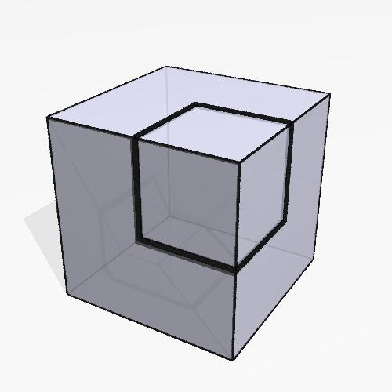
- Cavity shape: Cube.
- Walls: Six equal square faces.
- Example: A cubic hollow region inside a larger cube.

Cylindrical Internal-Cavity Subtraction
# Source: AI Source: Provided by: [Data Path: Persons Table -> ID Column: 1, Name_En Column: Motasem Essam] -> From: [ChatGPT] on [7/25/2026]
Material is removed to create an internal cylindrical cavity.
- Cavity shape: Cylinder.
- Curved wall: Cylindrical surface.
- Ends: Usually circular.
- Example: A cylindrical hollow region inside a solid block.

Spherical Internal-Cavity Subtraction
# Source: AI Source: Provided by: [Data Path: Persons Table -> ID Column: 1, Name_En Column: Motasem Essam] -> From: [ChatGPT] on [7/25/2026]
Material is removed to create a spherical cavity.
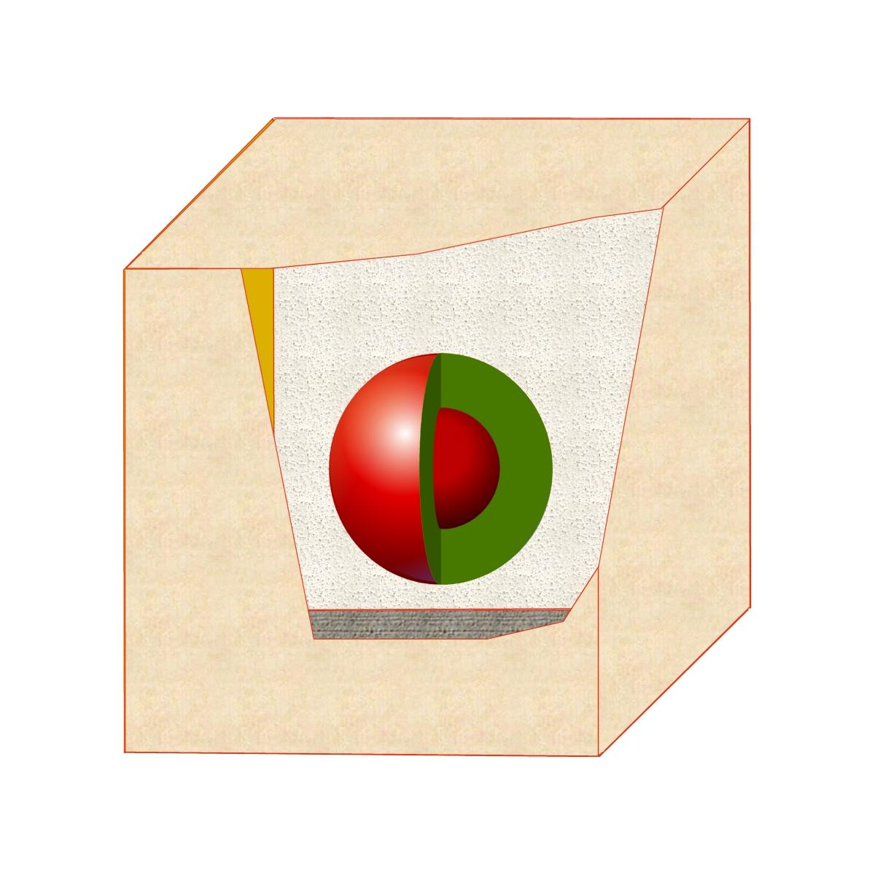
- Cavity shape: Sphere.
- Wall: Spherical surface.
- Example: A spherical hollow region inside a solid.

Hemispherical Internal-Cavity Subtraction
# Source: AI Source: Provided by: [Data Path: Persons Table -> ID Column: 1, Name_En Column: Motasem Essam] -> From: [ChatGPT] on [7/25/2026]
Material is removed to create a hemispherical internal cavity.
- Cavity shape: Hemisphere.
- Wall: Hemispherical curved surface.
- Base: Circular boundary.
- Example: A hemispherical hollow region inside a solid.

Conical Internal-Cavity Subtraction
# Source: AI Source: Provided by: [Data Path: Persons Table -> ID Column: 1, Name_En Column: Motasem Essam] -> From: [ChatGPT] on [7/25/2026]
Material is removed to create a conical cavity.
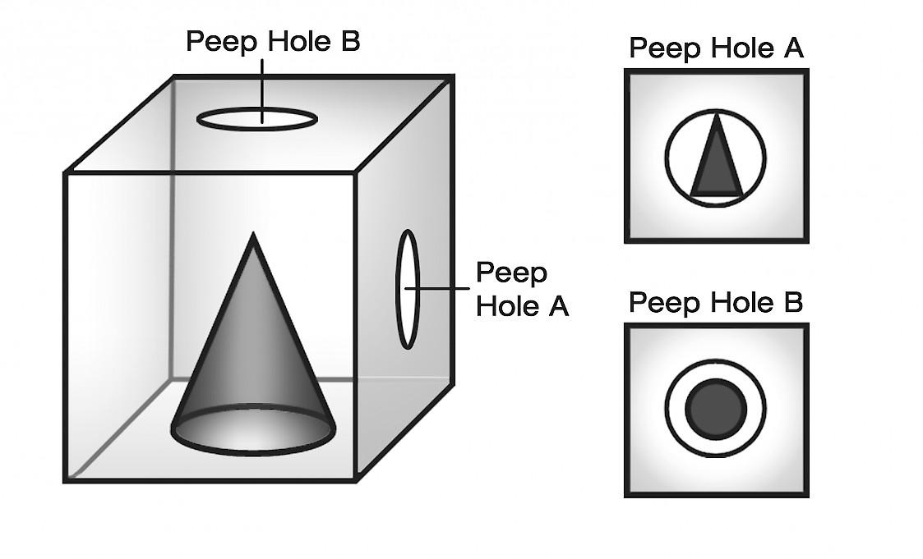
- Cavity shape: Cone.
- Wall: Conical surface.
- Base: Usually circular.
- Example: A conical hollow region inside a solid.

Pyramidal Internal-Cavity Subtraction
# Source: AI Source: Provided by: [Data Path: Persons Table -> ID Column: 1, Name_En Column: Motasem Essam] -> From: [ChatGPT] on [7/25/2026]
Material is removed to create a pyramid-shaped internal cavity.
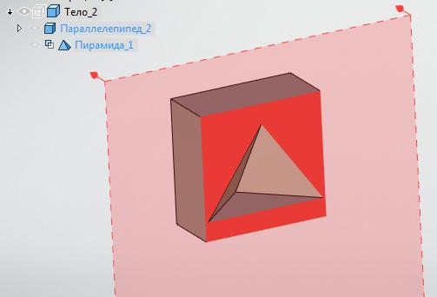
- Cavity shape: Pyramid.
- Walls: Triangular faces.
- Base: Polygonal.
- Example: A square-pyramidal cavity inside a larger solid.

Polygonal-Prismatic Internal-Cavity Subtraction
# Source: AI Source: Provided by: [Data Path: Persons Table -> ID Column: 1, Name_En Column: Motasem Essam] -> From: [ChatGPT] on [7/25/2026]
Material is removed to create a cavity with a polygonal cross-section and prismatic form.
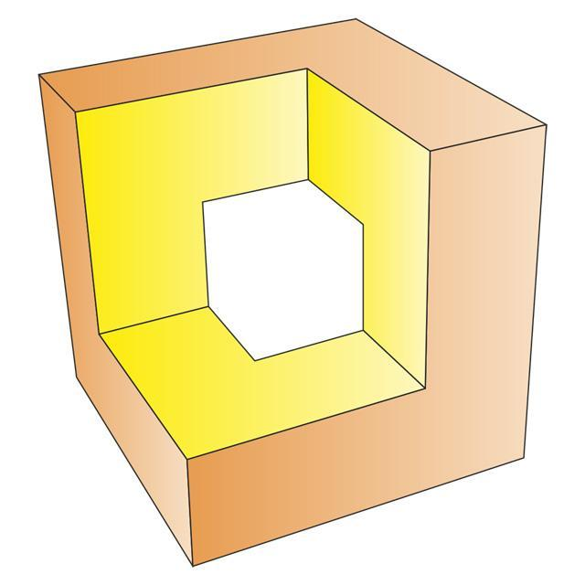
- Cavity shape: Polygonal prism.
- Walls: Flat polygonal or rectangular surfaces.
- Example: A hexagonal-prismatic cavity inside a solid.

Irregular Internal-Cavity Subtraction
# Source: AI Source: Provided by: [Data Path: Persons Table -> ID Column: 1, Name_En Column: Motasem Essam] -> From: [ChatGPT] on [7/25/2026]
Material is removed to create an internal cavity with an irregular geometric shape.
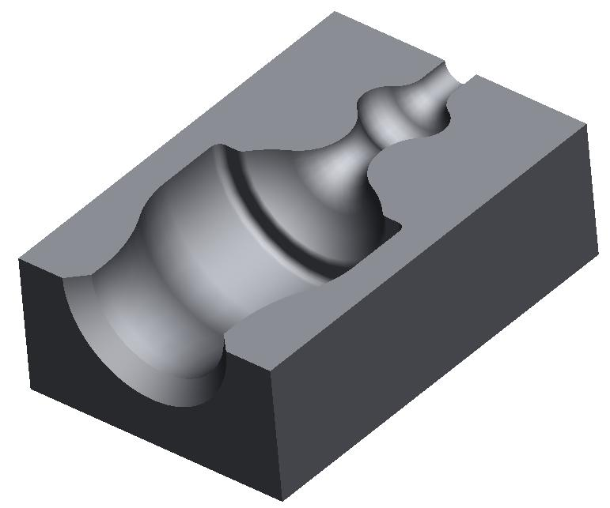
- Cavity shape: Irregular.
- Walls: May be flat, curved, or mixed.
- Example: An irregular internal hollow region.

Mixed-Shape Internal-Cavity Subtraction
# Source: AI Source: Provided by: [Data Path: Persons Table -> ID Column: 1, Name_En Column: Motasem Essam] -> From: [ChatGPT] on [7/25/2026]
Material is removed to create an internal cavity composed of two or more different geometric regions.
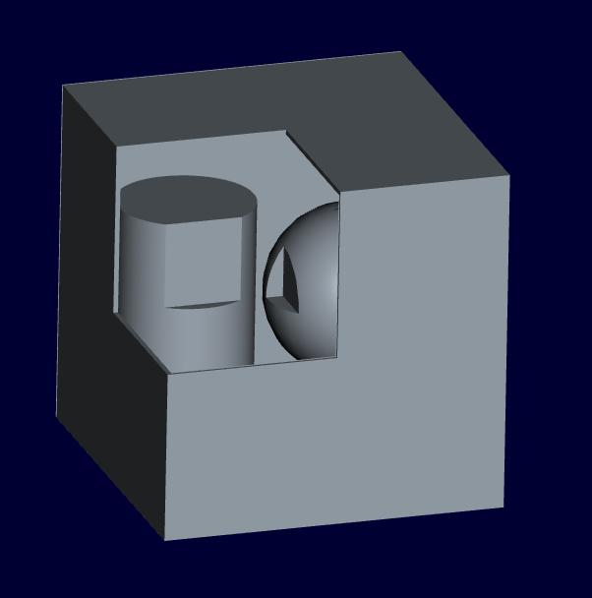
- Cavity shape: Combination of different geometric solids.
- Walls: Flat, curved, or mixed.
- Example: A rectangular chamber connected to a cylindrical chamber.

Classification by Cavity Enclosure
# Source: AI Source: Provided by: [Data Path: Persons Table -> ID Column: 1, Name_En Column: Motasem Essam] -> From: [ChatGPT] on [7/25/2026]
Internal cavities can be classified according to their connection with the exterior.

Fully Enclosed Cavity
# Source: AI Source: Provided by: [Data Path: Persons Table -> ID Column: 1, Name_En Column: Motasem Essam] -> From: [ChatGPT] on [7/25/2026]
The cavity is completely surrounded by the remaining solid material and has no opening to the exterior.
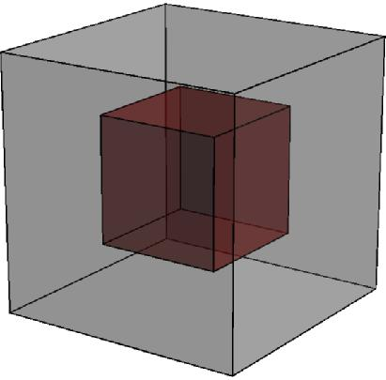
- No external opening.
- Entire cavity boundary is internal.
- Example: A hollow spherical region enclosed inside a solid block.

Partially Enclosed Cavity
# Source: AI Source: Provided by: [Data Path: Persons Table -> ID Column: 1, Name_En Column: Motasem Essam] -> From: [ChatGPT] on [7/25/2026]
The cavity is surrounded by solid material but has one or more openings connecting it to the exterior.
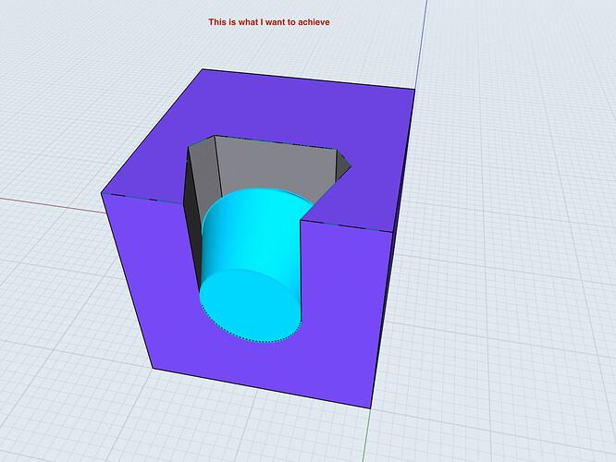
- Has an external opening.
- Most of the cavity remains surrounded by material.
- Example: An internal chamber connected to the surface through a narrow opening.

Connected Internal Cavities
# Source: AI Source: Provided by: [Data Path: Persons Table -> ID Column: 1, Name_En Column: Motasem Essam] -> From: [ChatGPT] on [7/25/2026]
Two or more internal cavities are connected through passages or shared openings.
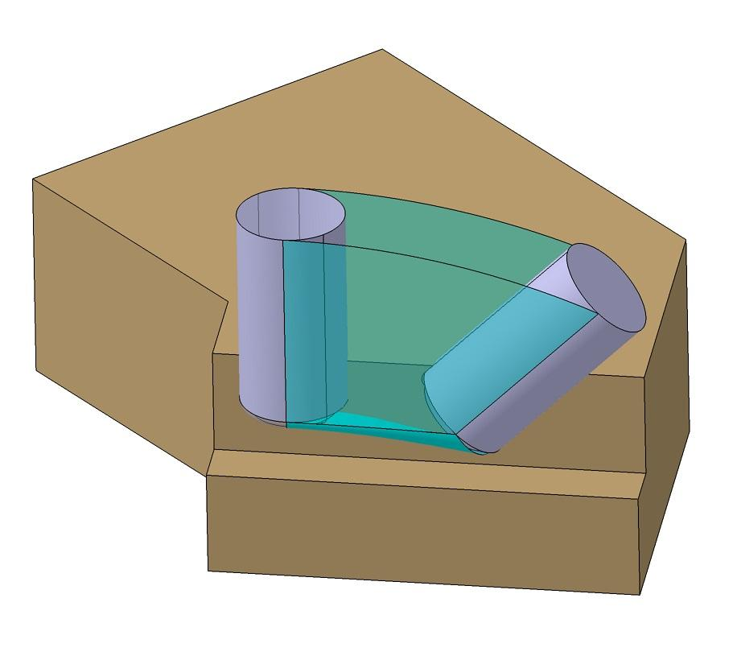
- Contains multiple cavity regions.
- Connected by one or more passages.
- Example: Two internal chambers connected by a cylindrical passage.

Isolated Internal Cavities
# Source: AI Source: Provided by: [Data Path: Persons Table -> ID Column: 1, Name_En Column: Motasem Essam] -> From: [ChatGPT] on [7/25/2026]
Two or more internal cavities exist separately without connecting to one another.
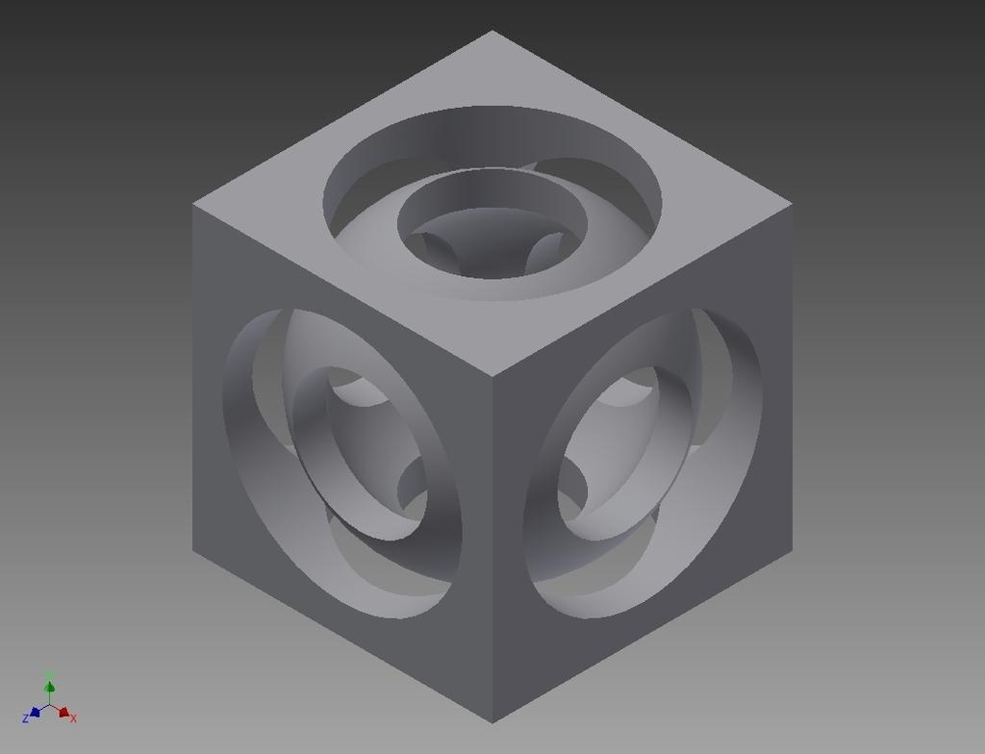
- Cavities are independent.
- Solid material separates them.
- Example: Multiple isolated hollow spaces inside a block.

Classification by Cavity Arrangement
# Source: AI Source: Provided by: [Data Path: Persons Table -> ID Column: 1, Name_En Column: Motasem Essam] -> From: [ChatGPT] on [7/25/2026]
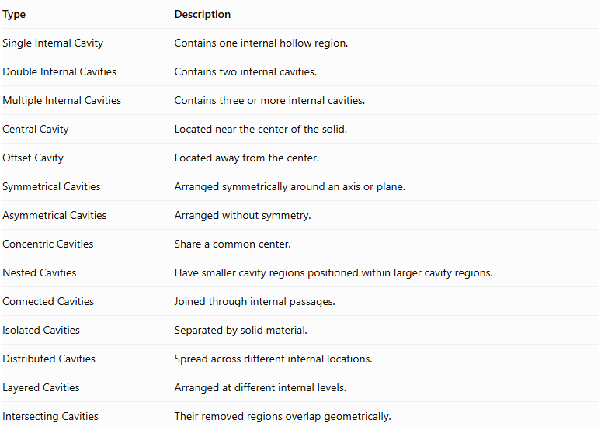
Type | Description
Single Internal Cavity | Contains one internal hollow region.
Double Internal Cavities | Contains two internal cavities.
Multiple Internal Cavities | Contains three or more internal cavities.
Central Cavity | Located near the center of the solid.
Offset Cavity | Located away from the center.
Symmetrical Cavities | Arranged symmetrically around an axis or plane.
Asymmetrical Cavities | Arranged without symmetry.
Concentric Cavities | Share a common center.
Nested Cavities | Have smaller cavity regions positioned within larger cavity regions.
Connected Cavities | Joined through internal passages.
Isolated Cavities | Separated by solid material.
Distributed Cavities | Spread across different internal locations.
Layered Cavities | Arranged at different internal levels.
Intersecting Cavities | Their removed regions overlap geometrically.
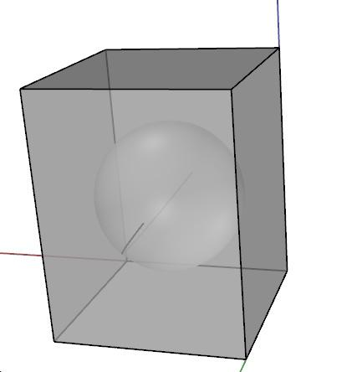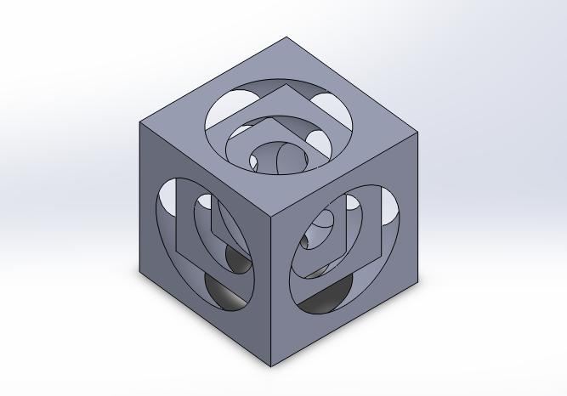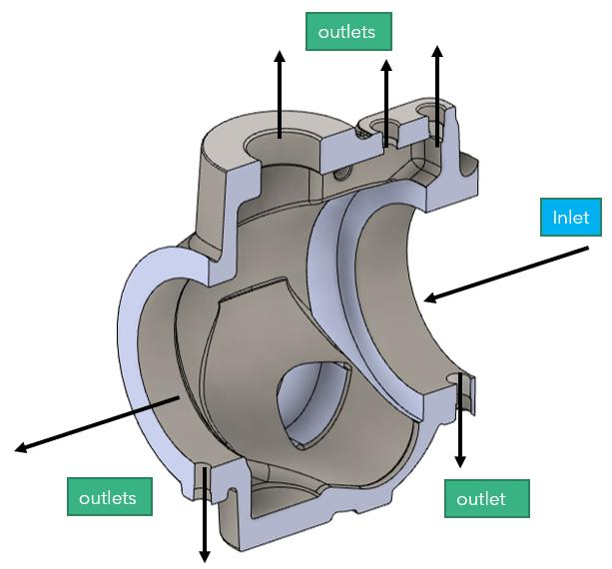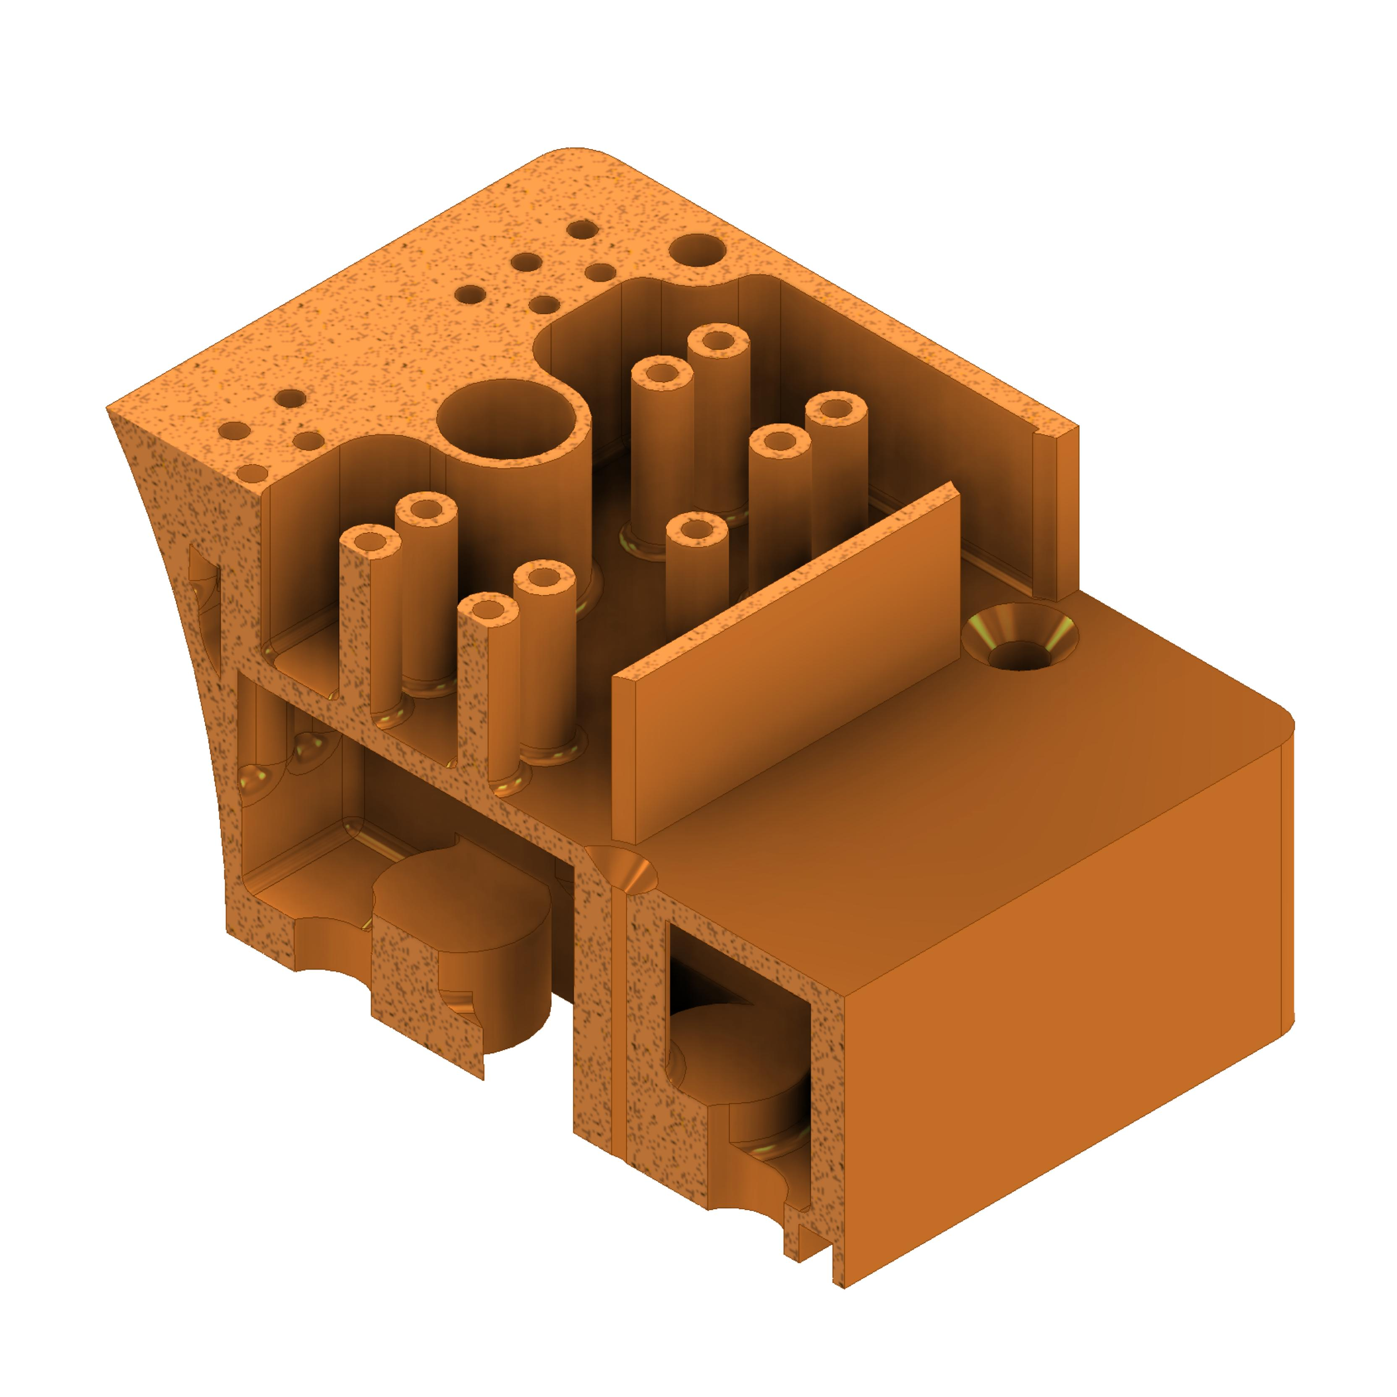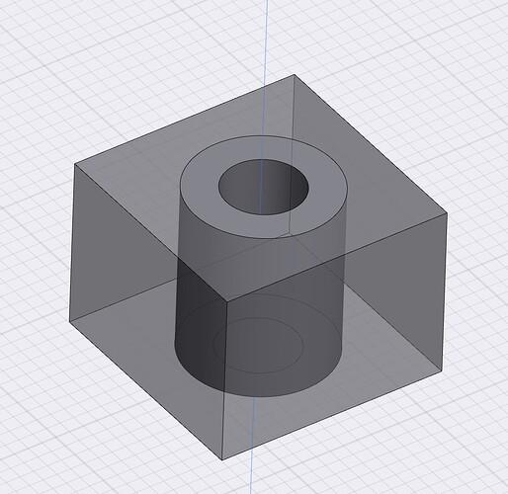

Classification by Cavity Wall Geometry
# Source: AI Source: Provided by: [Data Path: Persons Table -> ID Column: 1, Name_En Column: Motasem Essam] -> From: [ChatGPT] on [7/25/2026]
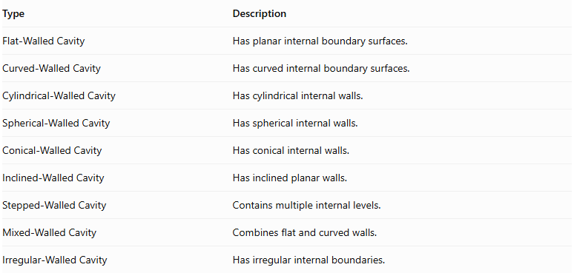
Type | Description
Flat-Walled Cavity | Has planar internal boundary surfaces.
Curved-Walled Cavity | Has curved internal boundary surfaces.
Cylindrical-Walled Cavity | Has cylindrical internal walls.
Spherical-Walled Cavity | Has spherical internal walls.
Conical-Walled Cavity | Has conical internal walls.
Inclined-Walled Cavity | Has inclined planar walls.
Stepped-Walled Cavity | Contains multiple internal levels.
Mixed-Walled Cavity | Combines flat and curved walls.
Irregular-Walled Cavity | Has irregular internal boundaries.

Classification by Cavity Depth and Dimensions
# Source: AI Source: Provided by: [Data Path: Persons Table -> ID Column: 1, Name_En Column: Motasem Essam] -> From: [ChatGPT] on [7/25/2026]
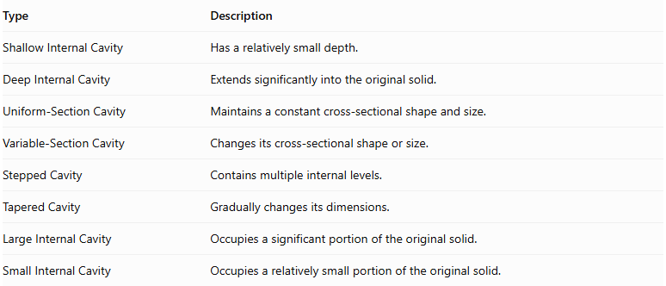
Type | Description
Shallow Internal Cavity | Has a relatively small depth.
Deep Internal Cavity | Extends significantly into the original solid.
Uniform-Section Cavity | Maintains a constant cross-sectional shape and size.
Variable-Section Cavity | Changes its cross-sectional shape or size.
Stepped Cavity | Contains multiple internal levels.
Tapered Cavity | Gradually changes its dimensions.
Large Internal Cavity | Occupies a significant portion of the original solid.
Small Internal Cavity | Occupies a relatively small portion of the original solid.

Mathematical Properties and Formulas

Remaining Volume
# Source: AI Source: Provided by: [Data Path: Persons Table -> ID Column: 1, Name_En Column: Motasem Essam] -> From: [ChatGPT] on [7/25/2026]
The remaining volume is calculated by subtracting the internal cavity volume from the original solid volume.
$$\boxed{V_{r}=V_{o}-V_{c}}$$
Where:
- $V_{r}$ = Remaining solid volume.
- $V_{o}$ = Original solid volume.
- $V_{c}$ = Internal cavity volume.
For multiple non-overlapping cavities:
$$\boxed{V_{r}=V_{o}-\sum_{i=1}^{n}{V_{c_{i}}}}$$
If cavity regions overlap, their common volume must be counted only once.

Common Internal-Cavity Volume Formulas
# Source: AI Source: Provided by: [Data Path: Persons Table -> ID Column: 1, Name_En Column: Motasem Essam] -> From: [ChatGPT] on [7/25/2026]
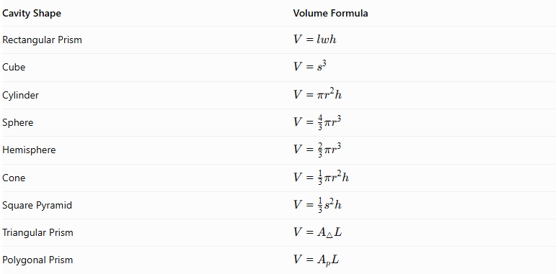
Cavity Shape | Volume Formula
Rectangular Prism | $$V=lwh$$
Cube | $$V=s^{3}$$
Cylinder | $$V=πr^{2}h$$
Sphere | $$V=\frac{4}{3}πr^{3}$$
Hemisphere | $$V=\frac{2}{3}πr^{3}$$
Cone | $$V=\frac{1}{3}πr^{2}h$$
Square Pyramid | $$V=\frac{1}{3}s^{2}h$$
Triangular Prism | $$V=A_{triangle}L$$
Polygonal Prism | $$V=A_{pL}$$

Surface Area
# Source: AI Source: Provided by: [Data Path: Persons Table -> ID Column: 1, Name_En Column: Motasem Essam] -> From: [ChatGPT] on [7/25/2026]
Internal-cavity subtraction introduces new internal surfaces. These surfaces must be included when calculating the total boundary surface area of the remaining material.
$$\boxed{{SA}_{r}={SA}_{o}-A_{opening}+A_{internal}}$$
Where:
- ${SA}_{r}$ = Total boundary surface area of the remaining solid.
- ${SA}_{o}$ = Original external surface area.
- $A_{opening}$ = Original exterior area removed to create cavity openings.
- $A_{internal}$ = Newly exposed internal cavity surface area.
For a completely enclosed cavity, there is no opening in the original external surface:
$$\boxed{{SA}_{r}={SA}_{o}+A_{cavity wall}}$$
For a partially enclosed cavity, the external opening area must be subtracted before adding the new internal surfaces.
Important distinction: The total boundary surface area includes the cavity walls. If only the externally visible surface area is required, the internal cavity surfaces must be excluded.

Worked Examples

Example 1: Cubical Internal Cavity
# Source: AI Source: Provided by: [Data Path: Persons Table -> ID Column: 1, Name_En Column: Motasem Essam] -> From: [ChatGPT] on [7/25/2026]
A solid cube has a side length of 12 cm. A smaller cubic cavity is removed from its interior.
The cavity has:
- Side length = 4 cm.
- Position = Completely enclosed inside the cube.
Find the remaining volume and total boundary surface area.
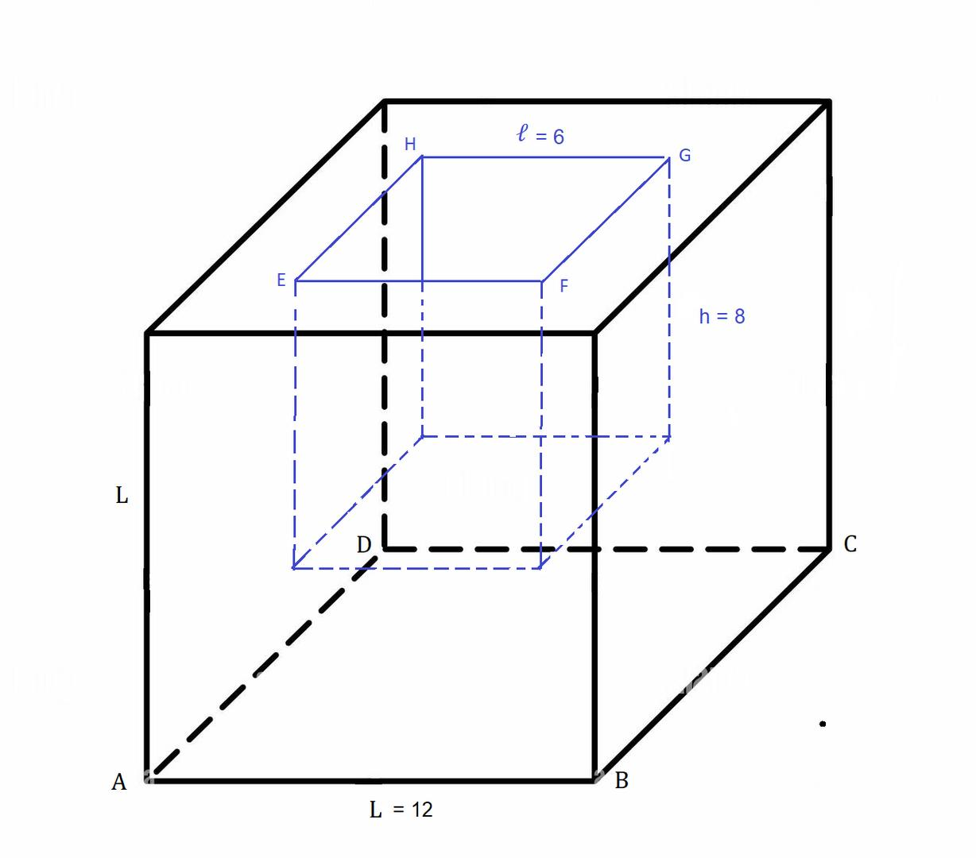
Step 1: Calculate the original volume.
$$V_{o}={12}^{3}$$
$$V_{o}=1728{ cm}^{3}$$
Step 2: Calculate the cavity volume.
$$V_{c}=4^{3}$$
$$V_{c}=64{ cm}^{3}$$
Step 3: Calculate the remaining volume.
$$V_{r}=1728-64$$
$$\boxed{V_{r}=1664{ cm}^{3}}$$
Step 4: Calculate the original surface area.
$${SA}_{o}=6({12}^{2})$$
$${SA}_{o}=864{ cm}^{2}$$
Step 5: Calculate the internal cavity surface area.
The cavity has six square internal faces:
$${SA}_{c}=6(4^{2})$$
$${SA}_{c}=96{ cm}^{2}$$
Step 6: Calculate the total boundary surface area.
Because the cavity is completely enclosed, no original exterior surface is removed.
$${SA}_{r}=864+96$$
$$\boxed{{SA}_{r}=960{ cm}^{2}}$$
Final Answer:
- Remaining Volume = 1664 cm³
- Total Boundary Surface Area = 960 cm²

Example 2: Spherical Internal Cavity
# Source: AI Source: Provided by: [Data Path: Persons Table -> ID Column: 1, Name_En Column: Motasem Essam] -> From: [ChatGPT] on [7/25/2026]
A solid cube has a side length of 10 cm. A spherical cavity is removed from its interior.
The cavity has:
- Radius = 3 cm.
- Position = Completely enclosed inside the cube.
Find the remaining volume and total boundary surface area.
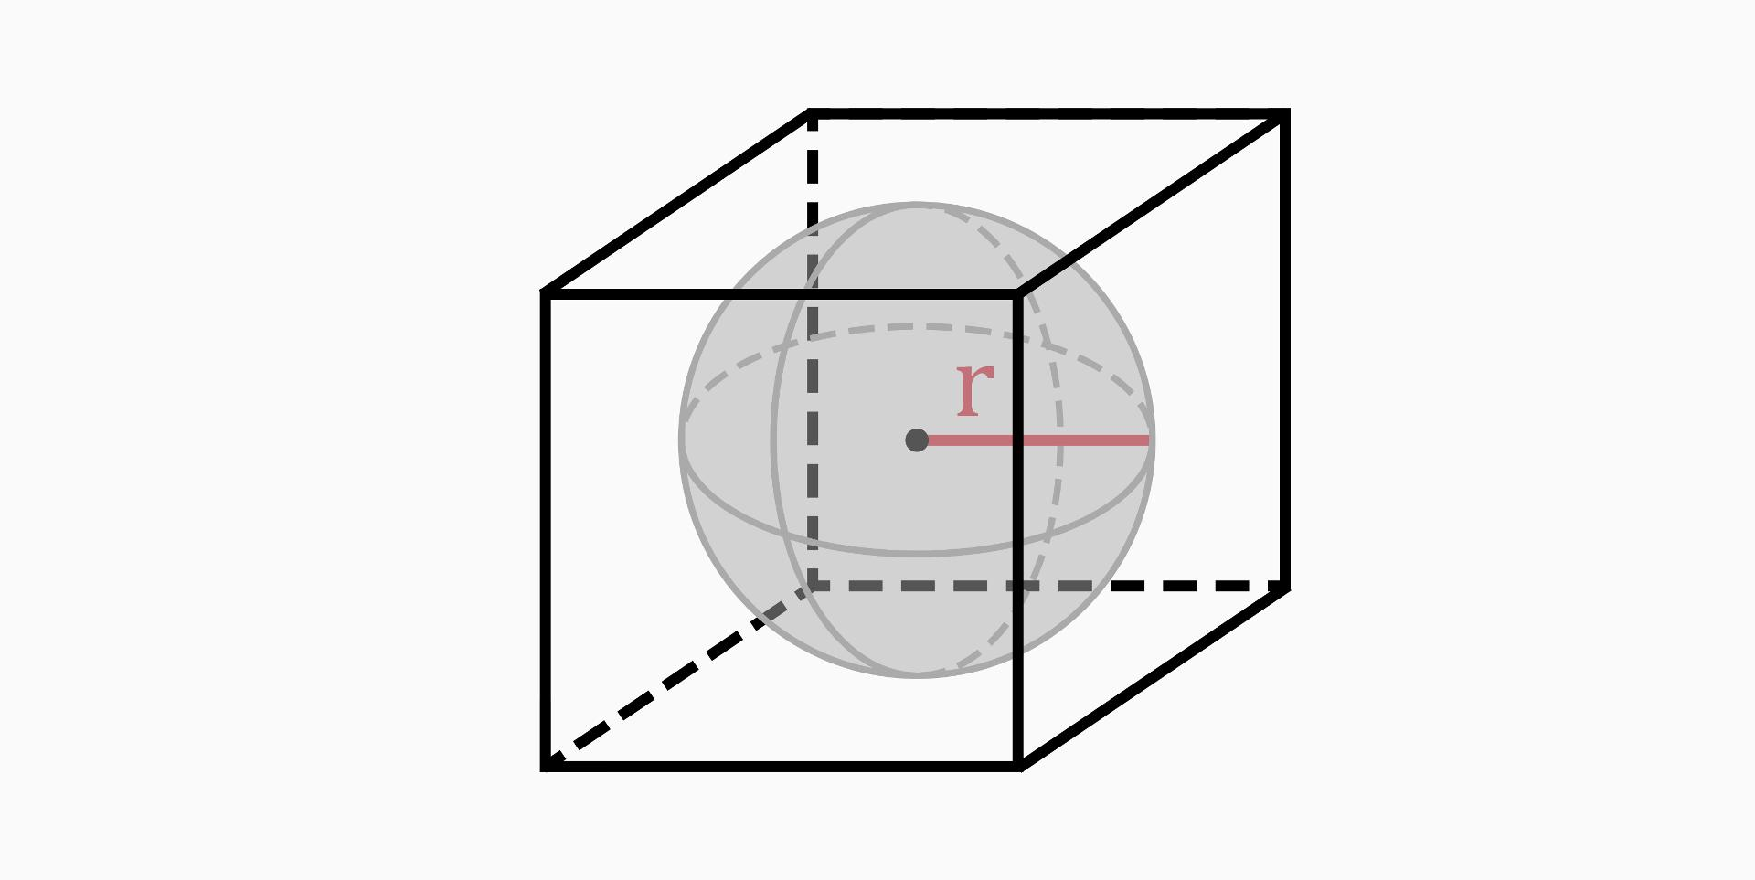
Step 1: Calculate the original volume.
$$V_{o}={10}^{3}$$
$$V_{o}=1000{ cm}^{3}$$
Step 2: Calculate the spherical cavity volume.
$$V_{c}=\frac{4}{3}πr^{3}$$
$$=\frac{4}{3}π(3)^{3}$$
$$V_{c}=36π{ cm}^{3}$$
Step 3: Calculate the remaining volume.
$$V_{r}=1000-36π$$
$$\boxed{V_{r}≈886.90{ cm}^{3}}$$
Step 4: Calculate the original surface area.
$${SA}_{o}=6({10}^{2})$$
$${SA}_{o}=600{ cm}^{2}$$
Step 5: Calculate the spherical cavity surface area.
$${SA}_{c}=4πr^{2}$$
$$=4π(3)^{2}$$
$${SA}_{c}=36π{ cm}^{2}$$
Step 6: Calculate the total boundary surface area.
$${SA}_{r}=600+36π$$
$$\boxed{{SA}_{r}≈713.10{ cm}^{2}}$$
Final Answer:
- Remaining Volume = 886.90 cm³
- Total Boundary Surface Area = 713.10 cm²

Important Characteristics
# Source: AI Source: Provided by: [Data Path: Persons Table -> ID Column: 1, Name_En Column: Motasem Essam] -> From: [ChatGPT] on [7/25/2026]
- Material is removed from an interior region of an existing solid.
- The resulting solid contains one or more hollow spaces.
- A cavity may be fully enclosed or connected to the exterior through an opening.
- Its geometric shape may be regular, irregular, or mixed.
- Its internal walls may be flat, curved, inclined, or stepped.
- Multiple cavities may be connected or isolated.
- Cavities can be centrally located, offset, symmetrical, or asymmetrical.
- The remaining material volume is smaller than the original volume.
- The total boundary surface area includes internal cavity walls.
- A completely enclosed cavity does not necessarily create any visible opening on the outside of the solid.

Comparison with Other Subtraction Methods
# Source: AI Source: Provided by: [Data Path: Persons Table -> ID Column: 1, Name_En Column: Motasem Essam] -> From: [ChatGPT] on [7/25/2026]
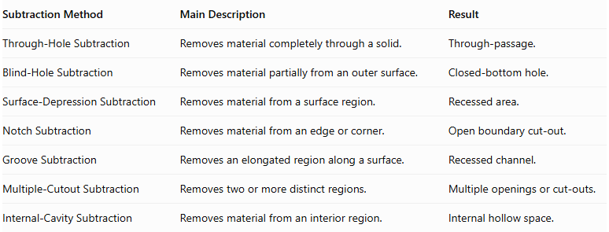
Subtraction Method | Main Description | Result
Through-Hole Subtraction | Removes material completely through a solid. | Through-passage.
Blind-Hole Subtraction | Removes material partially from an outer surface. | Closed-bottom hole.
Surface-Depression Subtraction | Removes material from a surface region. | Recessed area.
Notch Subtraction | Removes material from an edge or corner. | Open boundary cut-out.
Groove Subtraction | Removes an elongated region along a surface. | Recessed channel.
Multiple-Cutout Subtraction | Removes two or more distinct regions. | Multiple openings or cut-outs.
Internal-Cavity Subtraction | Removes material from an interior region. | Internal hollow space.
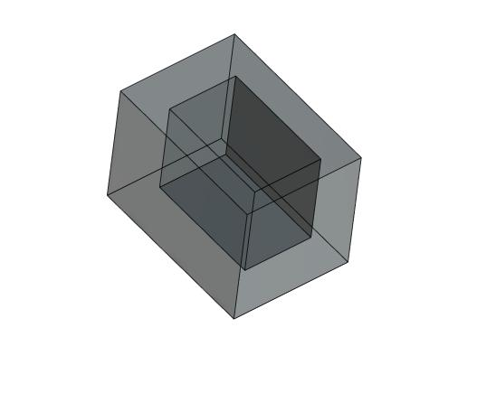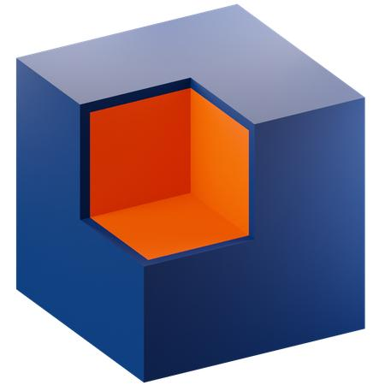
Important distinction: An internal cavity is defined by its interior location and hollow structure. A through-hole connects opposite exterior regions, while a blind hole begins at an external surface and terminates inside the solid. A fully enclosed internal cavity has no direct connection to the exterior.

Applications
# Source: AI Source: Provided by: [Data Path: Persons Table -> ID Column: 1, Name_En Column: Motasem Essam] -> From: [ChatGPT] on [7/25/2026]
Internal-cavity subtraction is commonly used in:
- Mechanical engineering: hollow machine components and internal chambers.
- Manufacturing: internal pockets and enclosed compartments.
- Aerospace engineering: lightweight hollow structural components.
- Automotive engineering: internal passages and fluid chambers.
- Architecture: hollow structural sections and internal voids.
- Product design: internal compartments and protective housings.
- Electronics: enclosed component spaces and internal enclosures.
- Industrial design: hollow molded products.
- Fluid systems: internal chambers and reservoirs.
- Engineering modeling: lightweight solids with internal voids.

Key Points
# Source: AI Source: Provided by: [Data Path: Persons Table -> ID Column: 1, Name_En Column: Motasem Essam] -> From: [ChatGPT] on [7/25/2026]
- Internal-cavity subtraction removes material from the interior of a solid.
- It creates an internal hollow region or cavity.
- Cavities can be rectangular, cubical, cylindrical, spherical, conical, pyramidal, polygonal, irregular, or mixed.
- They may be fully enclosed, partially enclosed, connected, or isolated.
- Remaining volume equals original volume minus removed cavity volume, with overlap corrections where necessary.
- Total boundary surface area includes the newly exposed internal cavity surfaces.
- A fully enclosed cavity does not require an external opening.

Conclusion
# Source: AI Source: Provided by: [Data Path: Persons Table -> ID Column: 1, Name_En Column: Motasem Essam] -> From: [ChatGPT] on [7/25/2026]
Internal-Cavity Subtraction is an important classification of composite solids formed by subtraction. It involves removing material from an interior region of an existing solid to create an enclosed or partially enclosed hollow space.
Internal cavities can vary in geometric shape, size, position, and connection to the exterior. Their classification and mathematical properties help describe hollow structures and calculate both the remaining material volume and the total boundary surface area accurately.

